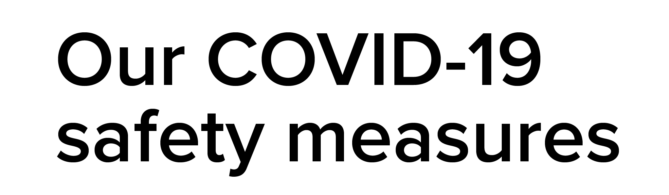

At **(AGENCY NAME),** we have put a number of precautions in place to ensure both our staff and visitors’ safety during the ongoing nature of COVID-19.



**Travel**

Please advise the team if you have returned from overseas in the last 14 days, or been in contact with anyone who has tested positive to COVID-19.



**Hygienic practice**

Please be advised we have also chosen to eliminate handshaking or other close contact greetings between our people as well as any visitors to our offices.

We appreciate your understanding and cooperation.

Many thanks,

The Property Management Team

(AGENCY NAME)